**Data Analytics with Tableau**

by

**SmartInternz**

**Project Name:** Visualizing housing market trends: Analysis of sale prices and features

**Project Id:** LTVIP2025TMID49893

# Project Mentor: Manoj

**Team Members:**

|  |  |  |
| --- | --- | --- |
| 1. Hari Priya Sikhinam | | (Reg.No.22HUlA4451) |
| 2. Sai Sreeja Karanam |  | (Reg.No.22HU1A44) |
| 3. Syed Abdul Hameed |  | (Reg.No.22HM1A3339) |
| 4. Raviteja Reddicherla |  | (Reg.No.22HM1A3330) |

DEPARTMENT OF **CSE (Data Science), RV Institute of Technology , Chebrolu , Bapatla (Dist) , Andhra Pradesh.**

# ACKNOWLEDGEMENT

I am pleased to acknowledge my sincere thanks to **RV** **Institute** of **Technology** for their kind encouragement in doing this project and for completing it successfully.

I would also like to thank my fellow team members and peers for their collaboration, encouragement and help in overcoming various technical and analytical challenges.

# ABSTRACT

This project, titled **“Visualizing Housing Market Trends: An Analysis of Sale Prices and Features,”** focuses on transforming extensive housing data into clear, insightful visual stories using Tableau. The project began by cleaning and preparing a dataset containing detailed attributes such as sale price, number of bedrooms, bathrooms, total area, house age, renovation status, and location.

Through the creation of calculated fields (like TotalAreaSqft, SalePriceBin, and HouseAge) and implementation of dynamic filters (e.g., by bedroom count, renovation status, condition, and price range), meaningful patterns were uncovered to help understand buyer preferences and market dynamics. Interactive dashboards and a story were designed to showcase trends year-wise, analyze house styles and garages, and evaluate renovation effects.

These visualizations were then embedded into a web interface, enabling easy access for stakeholders. The solution empowers home buyers, sellers, and real estate professionals to make data-driven decisions confidently. With its scalable and user-friendly design, this project sets a strong foundation for future expansion, such as including predictive price models, integrating real-time market data, and extending analysis to other regions.

.

***Key Words***:

* Tableau Dashboard
* Housing Market Analysis
* Data Visualization
* Sale Price Prediction
* Renovation Insights

**Project Report Format**

## 1. INTRODUCTION

1.1 Project Overview

1.2 Purpose

## 2. IDEATIONPHASE

2.1 Problem Statement

2.2 Empathy MapCanvas

2.3 Brainstorming

## 3. REQUIREMENTANALYSIS

3.1 CustomerJourneymap

3.2 Solution Requirement

3.3 Dataflow Diagram

3.4 Technology Stack

## 4. PROJECTDESIGN

4.1 Problem Solution Fit

4.2 Proposed Solution

4.3 Solution Architecture

1. **PROJECTPLANNING&SCHEDULING** 
   1. Project Planning
2. **FUNCTIONALANDPERFORMANCETESTING** 
   1. Performance Testing
3. **RESULTS** 
   1. Output Screenshots

## 8. ADVANTAGES&DISADVANTAGES

## 9. CONCLUSION

## 10. FUTURESCOPE

## 1. Introduction

The real estate market is shaped by multiple factors, including house age, renovation status, number of bedrooms and bathrooms, total living area, and overall condition. This project aims to analyze housing market trends and visualize important insights using Tableau, helping uncover how various property features influence sale prices. By transforming complex housing data into clear and interactive visual stories, the project provides valuable guidance for potential buyers, sellers, and real estate professionals to make more informed, data-driven decisions.

### 1.1. Project overviews

The dataset used in this project contains transformed housing data from the Ames Housing dataset, including 2,930 house sale records with detailed property features such as sale price, area, number of bedrooms, number of bathrooms, garage information, house age, condition, and renovation status. There are a total of 82 columns, where **Sale Price** is treated as the primary dependent variable. Other columns represent various physical and categorical features related to each house.

This project, titled **"Visualizing Housing Market Trends: An Analysis of Sale Prices and Features using Tableau,"** focuses on exploring and analyzing housing market trends through interactive visualizations. The main objective is to identify key factors influencing house prices — such as house age, style, renovation status, and number of bedrooms and bathrooms.

By leveraging Tableau, the project delivers interactive dashboards and a guided story to uncover patterns, compare trends across different years and styles, and provide insights into how specific features impact sale prices. This visual analysis empowers buyers, sellers, and real estate professionals to make confident, data-driven decisions, and lays the foundation for future extensions like predictive analytics and region-wise expansion.

#### 1.2. Objectives

• Identify and analyze the key features that influence house sale prices, such as age style, and condition.  
• Evaluate the impact of renovations and house age on overall property value.  
• Examine the distribution of house sales across various price segments and styles.  
• Develop interactive and visually engaging Tableau dashboards and stories to effectively communicate insights to stakeholders.

5

## 2.Project Initialization and Planning Phase

### 2.1. Define Problem Statement

|  |  |  |  |  |  |
| --- | --- | --- | --- | --- | --- |
| **Problem**  **Statement**  **(PS)** | **I am (Customer)** | **I’m trying**  **to** | **But** | **Because** | **Which makes me feel** |
| PS-1 | A first-time homebuyer seeking guidance | Find a home within my budget that meets my needs | The available market data is complex and fragmented | There is no centralized, user-friendly tool to analyze historical pricing trends | Confused and hesitant to make a decision |
| PS-2 | |  | | --- | |  |  |  | | --- | | A real estate investor aiming for higher returns | | Identify promising investment properties based on trends. | The raw data is difficult to analyze and lacks clear visual summaries | No interactive visualization tool allows me to compare property appreciation trends effectively | Frustrated and uncertain about investing |
| PS-3 | |  | | --- | |  |  |  | | --- | | A real estate agent supporting clients | | Provide quick, data-driven recommendations based on market insights | Market data is time-consuming to process and scattered across reports | There is no integrated tool to consolidate and visualize key pricing factors effectively | Less confident, slowing down client support |

6

2.2 Empathy Map Canvas

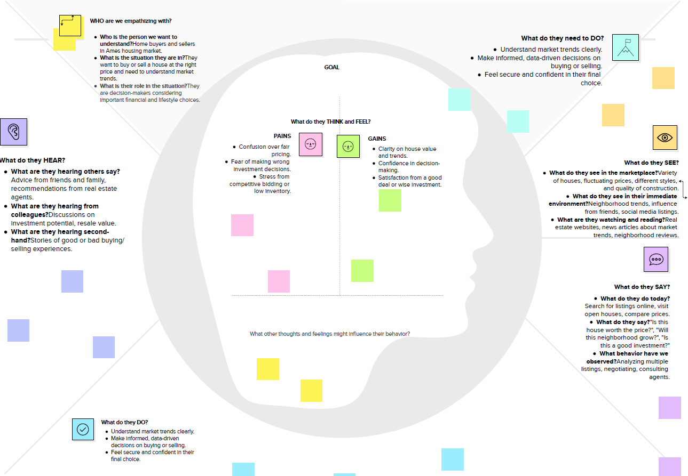

### 2.3 Brain Storming

**Step 1**: In the initial phase, we collaborated as a team to identify major challenges in the real estate market, especially regarding how different property features influence house sale prices. We explored multiple themes such as housing affordability, renovation effects, buyer preferences, regional price variations, and market dynamics. After careful discussions, we decided to focus on uncovering actionable insights hidden within housing data. The main objective was to visually analyze and present trends using Tableau so that buyers, sellers, investors, and policymakers could easily understand patterns in sale prices based on features like area, number of bedrooms and bathrooms, renovation status, condition, and location (zipcode groups). By defining this problem clearly, we aimed to support more data-driven, confident decision-making in the real estate sector.

**Problem Statement:**

How can housing sale price trends and property characteristics be visualized and analyzed using Tableau to identify patterns, improve buyer/seller decision-making, and uncover insights that support strategic real estate planning?

Team Members:

* Team Leader: S. Hari priya
* Team Member: K. Sai sreeja
* Team Member: K. Durga bhavani
* Team Member: M.Laasya

**Step 2:** Brainstorming, Idea Listing and Grouping

| **S.No** | **Idea Description** | **Category** |
| --- | --- | --- |
| 1 | Visualize average sale price by year and style | Pricing Insights |
| 2 | Analyze the impact of number of bedrooms on price | Property Features |
| 3 | Explore relationship between house age and sale price | Age-Based Analysis |
| 4 | Compare renovated vs. non-renovated home prices | Renovation Analysis |
| 5 | Group and analyze insights by zipcode clusters | Geographical Comparison |
| 6 | Analyze house condition impact on pricing | Quality-Based Pricing |
| 7 | Add calculated fields: House Age, Years Since Renovation | Data Preparation |
| 8 | Create Sale Price Bins for clearer price segmentation | Binning / Categorization |
| 9 | Build interactive Tableau dashboards combining these insights | Dashboard Design |
| 10 | Develop a Tableau Story to present a guided narrative | Storytelling |
| 11 | Add filters for bedrooms, bathrooms, condition, and renovation status | Interactive Exploration |

**Step 3**: Idea Prioritization Table

| **S.No** | **Idea Description** | **Impact** | **Feasibility** | **Priority** |
| --- | --- | --- | --- | --- |
| 1 | Visualize average sale price by year and style | High | Easy | High |
| 2 | Analyze impact of number of bedrooms on price | High | Easy | High |
| 3 | Explore house age vs. price relationship | High | Medium | High |
| 4 | Compare prices for renovated vs non-renovated homes | High | Medium | High |
| 5 | Group insights by zipcode clusters | Medium | Medium | Medium |
| 6 | Analyze house condition vs. price | High | Medium | High |
| 7 | Add calculated fields: House Age, Years Since Renovation | Medium | Easy | High |
| 8 | Create Sale Price Bins | Medium | Easy | High |
| 9 | Build interactive Tableau dashboards | High | Easy | High |
| 10 | Develop Tableau Story | High | Medium | High |
| 11 | Add filters for key features | Medium | Easy | Medium |

**2.4 Requirement Analysis**

**Customer Journey Map — Housing Market Trends Dashboard**

| **Stage** | **Actions & Touchpoints** | **Experience / Emotions** | **Pain Points** | **Opportunities** | **User Goals** |
| --- | --- | --- | --- | --- | --- |
| **Awareness** | Sees the Tableau dashboards shared on social media, newsletters, or Tableau Public; reads summaries and captions. | Curious, interested | Unsure if the dashboard is relevant; overwhelmed by too many charts. | Use clear, benefit-driven titles and engaging preview images. | Understand potential value and relevance quickly. |
| **Exploration** | Clicks through dashboards; interacts with filters such as house style, renovation status, and price bins; explores different years and conditions. | Engaged, inquisitive | May not know which filter combinations to use first. | Provide guided captions, highlight suggested filters, and add tooltips. | Learn patterns and compare options easily. |
| **Consideration** | Deep-dives into individual charts and story points; compares prices by style, age, and condition; considers options based on personal or investment needs. | Confident but cautious | May feel uncertain about data accuracy or completeness. | Include detailed legends, data notes, and explain calculated fields clearly. | Gain trust and make better comparisons. |
| **Decision** | Downloads insights, takes screenshots, or shares dashboard links; prepares to use insights for buying or selling decisions. | Empowered, decisive | Still may have hesitation about final purchase/investment move. | Add summary story points and final insight slides. | Support confident, data-backed decision-making. |

### 3.2 Solution Requirement

### ****Functional Requirements (FRs)****

* **FR-1: Data Import**
  + Import housing data from CSV files.
  + Enable the option for future integration with a live database (e.g., MySQL) to support real-time data updates.
* **FR-2: Data Cleaning & Transformation**
  + Handle missing or null values during preprocessing.
  + Create calculated fields such as House Age, Years Since Renovation, and TotalAreaSqft for enhanced analysis.
* **FR-3: Data Visualization**
  + Develop multiple interactive worksheets in Tableau to analyze different property features and trends.
  + Build comprehensive dashboards that combine these visualizations for holistic insights.
* **FR-4: User Interaction**
  + Provide filters to allow users to explore data by number of bedrooms, bathrooms, condition, renovation status, and zipcode clusters.
  + Enable comparative views such as bar charts, scatter plots, and price distributions.
* **FR-5: User Access**
  + Allow different roles (e.g., buyer, investor, agent) to access relevant visualizations and insights.
  + Offer options to export charts or download summary insights for offline use.
* **FR-6: Feedback & Iteration**
  + Allow for stakeholder feedback to improve visuals and usability.
  + Implement revision cycles based on feedback to refine dashboards and stories.

### ****Non-Functional Requirements (NFRs)****

* **NFR-1: Usability**
  + Dashboards should be intuitive, with clear legends, filters, and easy-to-understand navigation.
* **NFR-2: Security**
  + Ensure role-based access where applicable and secure any backend data connections.
* **NFR-3: Reliability**
  + System must handle unexpected or inconsistent data formats robustly, maintaining high data accuracy.
* **NFR-4: Performance**
  + Dashboards should load quickly and support smooth, responsive interactions.
* **NFR-5: Availability**
  + Dashboards must be accessible across different browsers and devices with minimal downtime.
* **NFR-6: Scalability**
  + Should be capable of handling larger datasets in future and support additional features or modules if expanded.

|  |  |  |
| --- | --- | --- |
| **No.** | **Functional Requirement (Epic) Sub Requirement (Story / Sub-Task)** | |
| FR-1 | **Data Import** | * Import data from CSV * Enable live database integration (MySQL) |
| FR-2 | **Data Cleaning & Transformation** | * Handle missing values * Add calculated fields like Year, Lockdown |
| FR-3 | **Data Visualization** | * Create Tableau worksheets * Build multiple dashboards |
| FR-4 | **User Interaction** | * Enable filtering by region, year * View comparative bar charts * Analyze pre/post-lockdown trends |
| FR-5 | **User Access** | * Role-based views for Analyst, Policy Maker,   Developer   * Download/export options |
| FR-6 | **Feedback Loop** | * Allow stakeholder feedback and change requests * Implement revision cycles |

### 3.3 Data Flow Diagram

A Data Flow Diagram (DFD) is a traditional visual representation of the information flows within a system. A neat and clear DFD can depict the right amount of the system requirement graphically. It shows how data enters and leaves the system, what changes the information, and where data is stored.

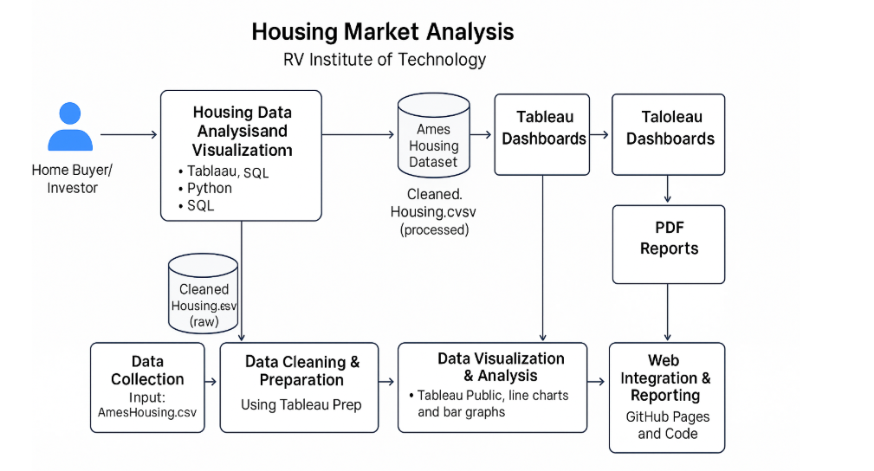

**User Stories**

Use the below template to list all the user stories for the product.

| **User Type** | **Functional Requirement (Epic)** | **User Story Number** | **User Story / Task** | **Acceptance criteria** | **Priority** | **Release** |
| --- | --- | --- | --- | --- | --- | --- |
| Customer (Buyer/Seller) | Data Visualization Access | USN-1 | As a user, I can view dashboards showing average house prices over years. | I can access and interpret price trends clearly. | High | Sprint-1 |
|  |  | USN-2 | As a user, I can filter data based on house age, renovation status, and location. | I can apply filters and see updated visualizations. | High | Sprint-1 |
|  | |  | | --- | |  |  |  | | --- | | Dashboard Interaction | | USN-3 | As a user, I can download reports or snapshots of dashboards for offline analysis. | As a user, I can download reports or snapshots of dashboards for offline analysis. | Medium | Sprint-2 |
|  | Dashboard Interaction | USN-4 | As a user, I can embed interactive dashboards into other platforms or websites. | Embedded dashboards work and are interactive. | Low | Sprint-2 |
| Data Analyst (Web User) | Data Preparation | USN-5 | As an analyst, I can upload cleaned data for visualizations. | Data uploads without errors and reflects in dashboards. | High | Sprint-1 |
|  | Data Analysis | USN-6 | As an analyst, I can perform performance testing and view data load metrics. | I can see data size and confirm smooth rendering. | Medium | Sprint-2 |
| Administrator | User Management | USN-7 | As an admin, I can manage user access to dashboards and stories. | I can grant or revoke access permissions. | High | Sprint-1 |
| Administrator | Monitoring & Reports | USN-8 | As an admin, I can track publishing history and monitor dashboard usage statistics. | I can generate and download usage reports. | Medium | Sprint-2 |

### 3.4 Technology Stack

**Table-1 Components and Technologies:**



| **S.No** | **Component** | **Description** | **Technology** |
| --- | --- | --- | --- |
| 1 | User Interface | Users interact via embedded dashboards on web pages | HTML, CSS, JavaScript |
| 2 | Application Logic-1 | Data preparation and cleaning logic | Tableau Prep, Excel |
| 3 | Application Logic-2 | Visualization logic and analysis | Tableau Public |
| 4 | Database | Cleaned dataset storage | CSV file (Cleaned_Housing.csv) |
| 5 | File Storage | Store Tableau packaged workbooks and HTML files | Local filesystem, GitHub Pages |
| 6 | External API | Tableau Public embedding for web integration | Tableau Public Embed API |
| 7 | Infrastructure | Hosting static web pages | GitHub Pages |

**Table-2 Application Characteristics:**

| **S.No** | **Characteristics** | **Description** | **Technology** |
| --- | --- | --- | --- |
| 1 | Open-Source Frameworks | GitHub Pages for static deployment, optional open JS libraries | GitHub Pages, HTML/CSS/JS |
| 2 | Security Implementations | Limited since it's public, basic repository protection | GitHub repo settings, HTTPS |
| 3 | Scalable Architecture | Can add more dashboards and stories in future | Static hosting, Tableau |
| 4 | Availability | High availability through GitHub global CDN | GitHub Pages CDN |
| 5 | Performance | Fast loading of static pages, lightweight HTML integration | GitHub Pages, CDN caching |

**Architecture Flow:**

GitHub Pages

(Static hosting)

Tableau Prep / Excel

(Data cleaning & transformation)

Tableau Public

(Dashboards & stories)

HTML, CSS, JavaScript

(Embedded dashboards)

Cleaned_Housing.csv

(Local storage)

AmesHousing.csv

(Raw dataset)

## 4. Project design

### 4.1 Problem Solution Fit

**Problem – Solution :**

The Problem-Solution Fit simply means that you have found a problem with your customer and that the solution you have realized for it actually solves the customer’s problem. It helps entrepreneurs, marketers and corporate innovators identify behavioral patterns and recognize what would work and why

**Purpose:**

❑ Solve complex problems in a way that fits the state of your customers.

❑ Succeed faster and increase your solution adoption by tapping into existing mediums and channels of behavior.

❑ Sharpen your communication and marketing strategy with the right triggers and messaging.

❑ Increase touch-points with your company by finding the right problem-behavior fit and building trust by solving frequent annoyances, or urgent or costly problems.

❑ Understand the existing situation in order to improve it for your target group.

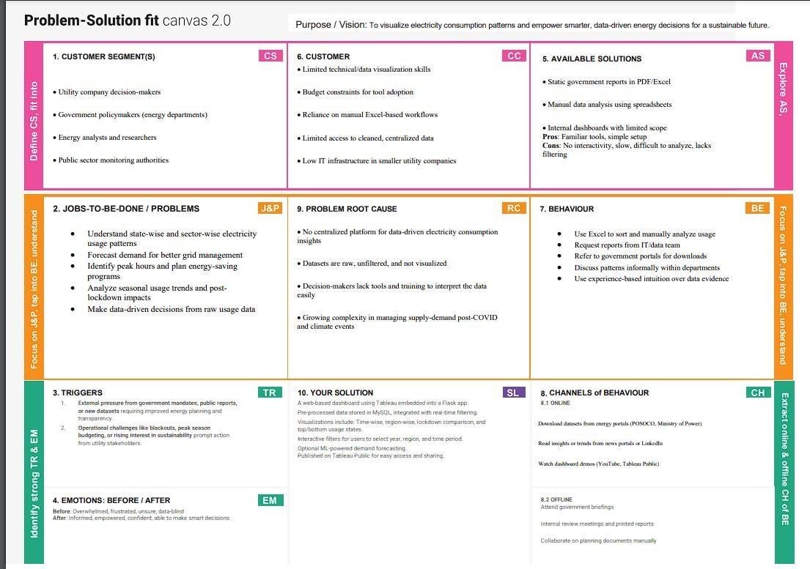

### 4.2 Proposed Solution

**Proposed Solution Template**

| **S.No.** | **Parameter** | **Description** |
| --- | --- | --- |
| 1 | **Problem Statement** | The real estate market involves complex and extensive datasets on housing features and sale prices. These datasets are often underutilized because of the lack of clear, accessible visualizations, making it challenging for buyers, sellers, and analysts to draw actionable insights and identify price trends. |
| 2 | **Idea / Solution Description** | Our solution transforms static housing data into dynamic, interactive visualizations using Tableau. The project includes data cleaning and preparation (e.g., handling nulls, renaming columns), creating calculated fields (like House Age and TotalAreaSqft), and developing dashboards and stories that highlight key price trends and feature-based comparisons. These dashboards are then embedded into a web page for easy accessibility. |
| 3 | **Novelty / Uniqueness** | This project leverages Tableau’s powerful visualization capabilities to move beyond standard charts. By integrating calculated fields, binning, condition-based segmentation, and geographic grouping, the solution provides an engaging, detailed exploration of how features such as bedrooms, area, renovation status, and house age influence sale prices. |
| 4 | **Social Impact / Customer Satisfaction** | The solution empowers home buyers, sellers, investors, and real estate agents to make informed, data-driven decisions. It improves market transparency, supports strategic planning, and enhances user confidence by presenting insights through clear, interactive visuals. |
| 5 | **Business Model (Revenue Model)** | This solution can be scaled as a subscription-based SaaS (Software as a Service) offering for real estate agencies, market researchers, and consultancy firms. Additional features such as live market integration, predictive pricing modules, and advanced customization can be introduced as premium services for additional revenue. |
| 6 | **Scalability of the Solution** | The system is designed to be scalable and flexible. It can be expanded to incorporate new datasets (e.g., rental trends, demographic data), cover additional cities or regions, and integrate future machine learning models for price prediction and recommendation, offering strong long-term growth potential. |

### 4.3 Solution Architecture

Solution architecture in this project is a crucial process that connects the **challenge of understanding housing market data** with a clear and effective **visual analytical solution.**

Its main objectives are to:  
● **Identify the most effective visualization and data preparation tools** (Tableau, Tableau Prep, GitHub Pages) to simplify housing data analysis for buyers and investors.  
● **Describe the structure and flow** of data — from raw dataset preparation to final web-embedded dashboards — to all stakeholders.  
● **Define key features**, such as interactive dashboards, filters for house age and renovation status, and story-based guided analysis.  
● **Provide a clear framework** that specifies how the data should be cleaned, visualized, shared to ensure ace/ssibility, accuracy, and usability.

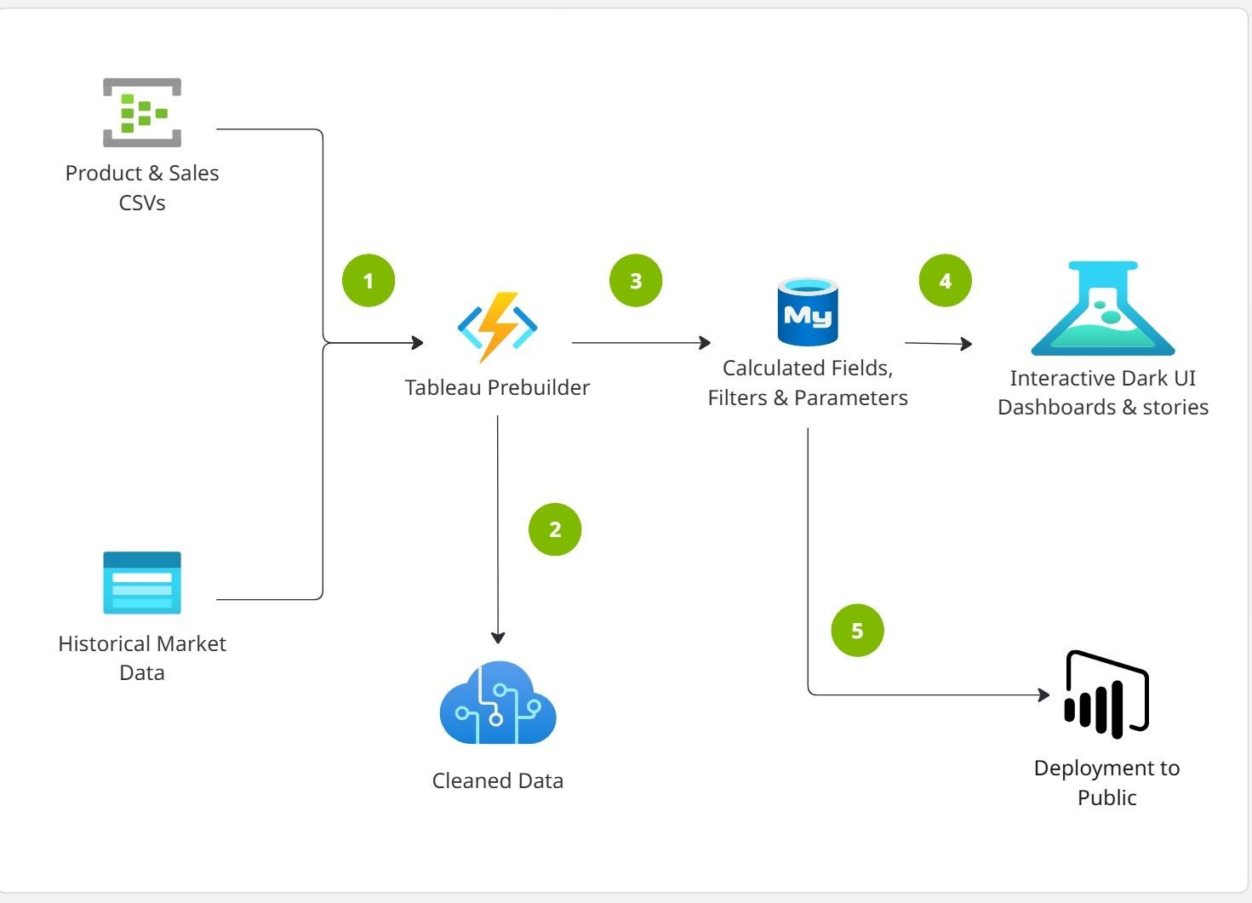

## 5. Project planning & scheduling

**Product Backlog, Sprint Schedule**

Use the below template to create product backlog and sprint schedule

| **Sprint** | **Epic** | **User Story No.** | **User Story / Task** | **Points** | **Priority** | **Assigned To** |
| --- | --- | --- | --- | --- | --- | --- |
| Sprnt-1 | Data Setup | USN-1 | As a user, I can upload housing data in CSV format | 3 | High | sreeja |
| Sprint-1 | Data Cleaning | USN-2 | As a developer, I can clean and preprocess housing data in Tableau Prep | 4 | High | Durga bhavani |
| Sprint-1 | Field Creation | USN-3 | As a user, I can create calculated fields like House Age | 2 | Medium | Lavanya kumari |
| Sprint-2 | Data Visualization | USN-4 | As a user, I can create sheets for price vs year, price vs house age | 5 | High | Hari priya |
| Sprint-2 | Dashboard Creation | USN-5 | As a user, I can build interactive Tableau dashboards with filters | 3 | High | Hari priya |
| Sprint-2 | Dashboard Styling | USN-6 | As a user, I can style dashboards for better readability and navigation | 2 | Medium | laasya |
| Sprint-3 | Storytelling | USN-7 | As a user, I can create a Tableau Story summarizing insights | 2 | Medium | lavanya |
| Sprint-3 | Web Integration | USN-8 | As a developer, I can embed dashboards into an HTML page using embed code | 4 | High | Hari priya |
| Sprint-3 | Embed Testing | USN-9 | As a user, I can test and review the embedded dashboard UI | 2 | Medium | Hari priya |
| Sprint-4 | Documentation | USN-10 | As a team, we can prepare final project documentation and report | 3 | High | Hari priya |
| Sprint-4 | Demo Preparation | USN-11 | As a team, we can prepare and rehearse final demo presentation | 2 | Medium | Hari priya |
| Sprint-4 | Bug Fixing | USN-12 | As a team, we can test and fix visual or logic bugs before submission | 2 | Medium | Hari priya |

**Project Tracker, Velocity :**

|  |  |  |  |  |  |  |
| --- | --- | --- | --- | --- | --- | --- |
| **Sprint** | **Total Story Points** | **Duration** | **Start Date** | **End Date** | **Points Completed** | **Release Date** |
| Sprint-1 | 9 | 4 Days | 11 June 2025 | 14 June 2025 | 9 | 14 June 2025 |
| Sprint-2 | 10 | 4 Days | 15 June 2025 | 18 June 2025 | 10 | 18 June 2025 |
| Sprint-3 | 8 | 4 Days | 19 June 2025 | 22 June 2025 | 8 | 22 June 2025 |
| Sprint-4 | 7 | 4 Days | 23 June 2025 | 26 June 2025 | 7 | 26 June 2025 |

## 6. Functional and performance testing

### 6.1 Performance Testing

**# smartbridge-housing-project**

**## Model Performance Test**

**### 1. Data Rendered**

The dataset used contains housing sales data with fields such as Sale Price, Number of Bedrooms, Bathrooms, Flat Area, Lot Area, Basement Area, House Age, Condition, Renovation Status, Zipcode Group, and others. The data was provided in .csv format and includes derived and transformed columns suitable for advanced analytics and visualizations in Tableau.

**### 2. Data Preprocessing**

Before importing the data into Tableau, preprocessing was done using Python (Pandas). The following steps were performed:

- Removed null or missing values.

- Renamed columns for clarity (e.g., “No of Bedrooms” → “Bedrooms”).

- Created calculated fields like “TotalAreaSqft” (sum of flat, lot, and basement areas).

- Generated dummy variables for house conditions and renovation status.

- Transformed categorical fields to improve Tableau usability.

The final cleaned dataset was stored and imported into Tableau for visualization.

**### 3. Utilization of Filters**

Multiple filters were implemented in Tableau to improve interactivity and user exploration. These include:

- Number of Bedrooms

- Number of Bathrooms

- House Condition

- Renovation Status (Yes/No)

- Zipcode Group

- Sale Price Bins

**### 4. Calculated Fields Used**

Several calculated fields were created in Tableau to enhance analysis and interactivity:

- TotalAreaSqft → [FlatAreaSqft] + [LotAreaSqft] + [BasementAreaSqft]

- SalePriceBin → Binning Sale Price into ₹100,000 intervals

- Condition_Excellent, Condition_Good, etc. → Dummy fields (0/1)

- Ever_Renovated_Yes → Dummy field to identify renovated homes

- AvgPrice → AVG([SalePrice]) for grouped insights

- HouseAge → Difference between year built and sale date if available (or derived field if pre-calculated)

**### 5. Dashboard**

Tableau dashboards were created integrating charts, filters, and KPIs for an interactive user experience.

**### 6. Story Design**

A Tableau story was developed to guide users step by step through the housing data insights and trends.

## 7. Results

### 7.1 Output Screenshots

**Activity1.1**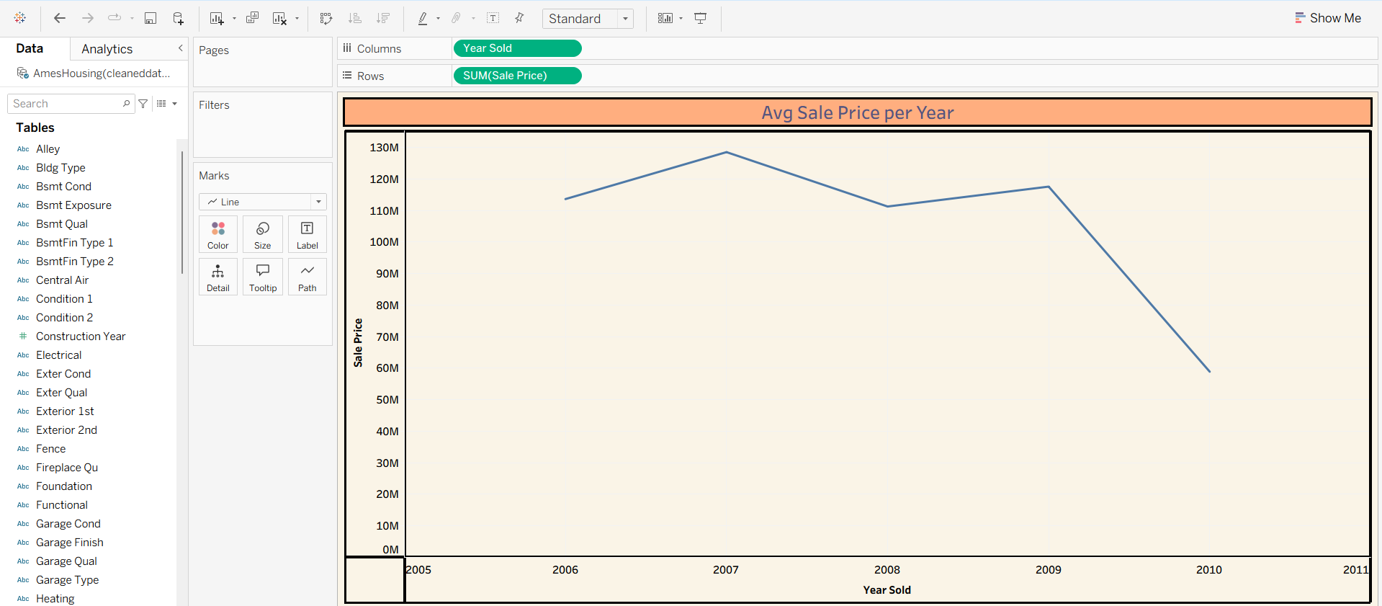

**Acativity1.2**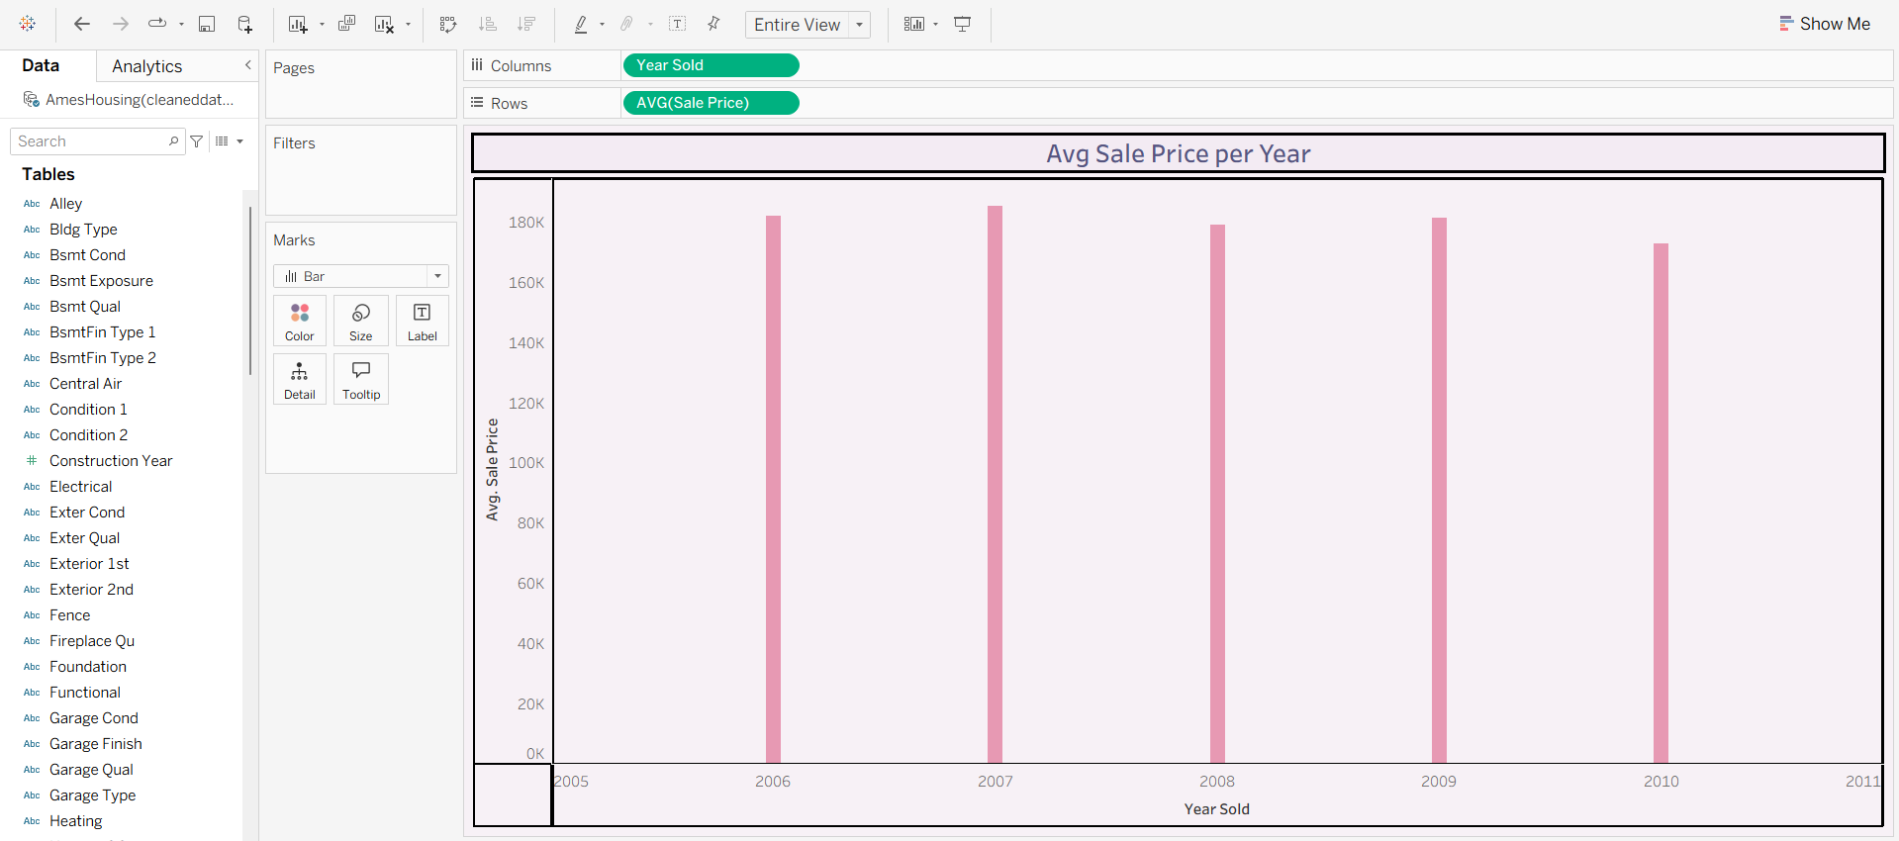

**Activity1.3**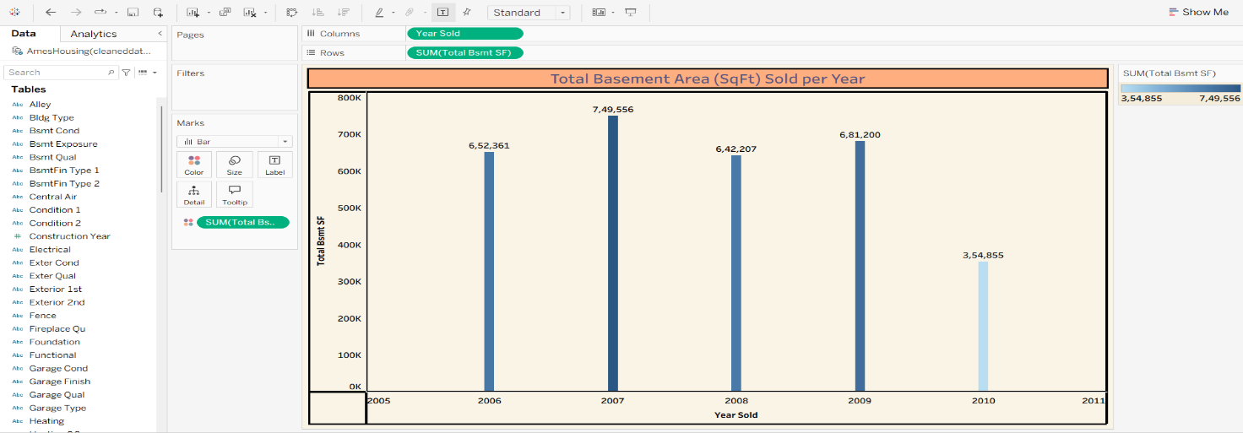

**Activity1.4**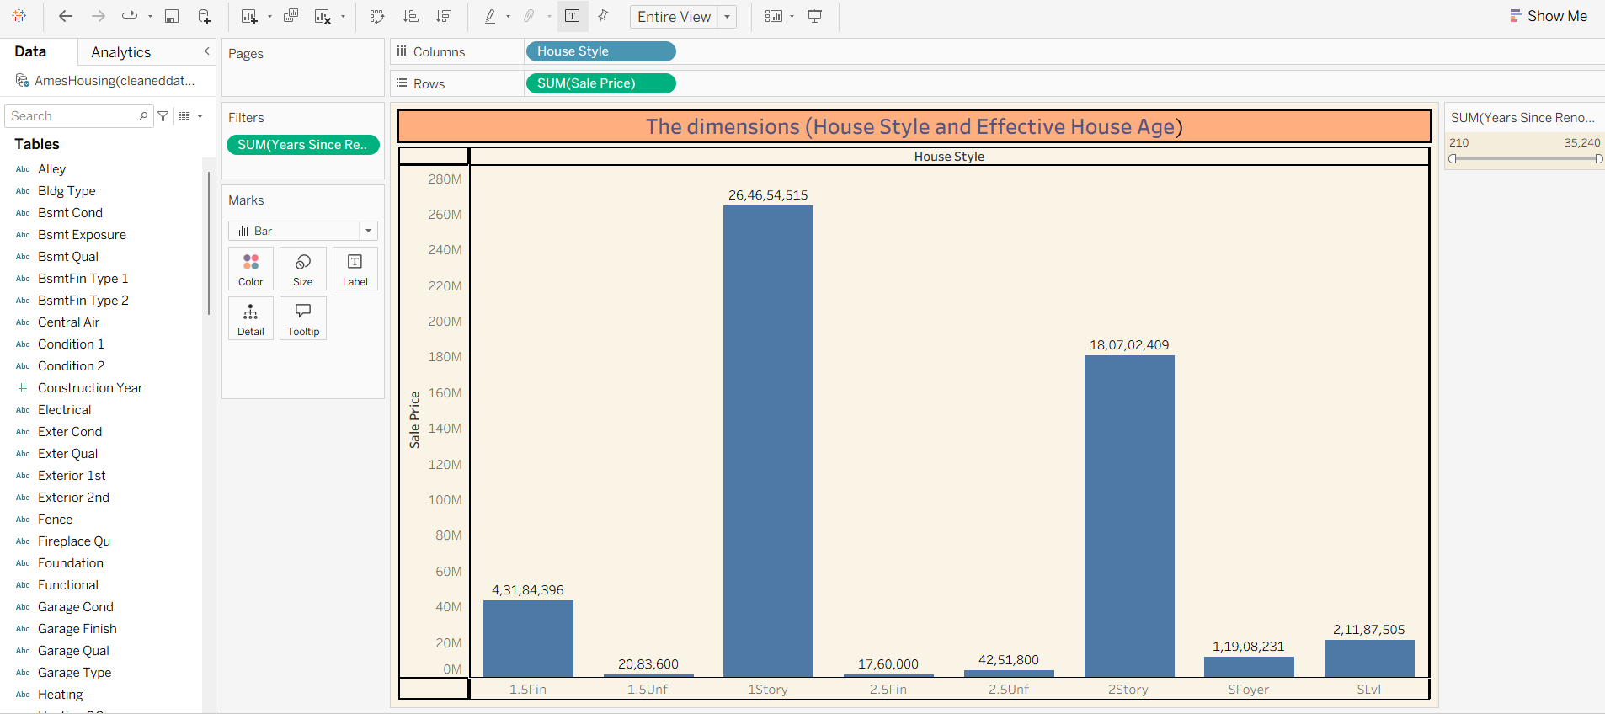

**Activity1.5**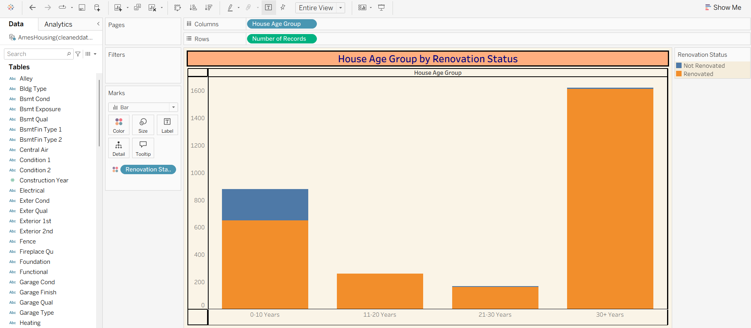

**Activity1.6**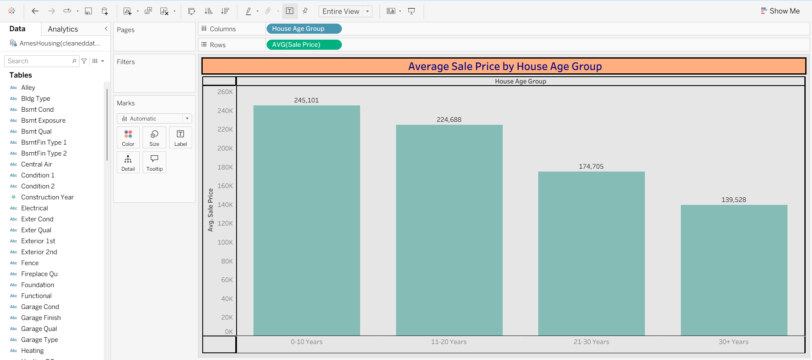

**Activity1.7**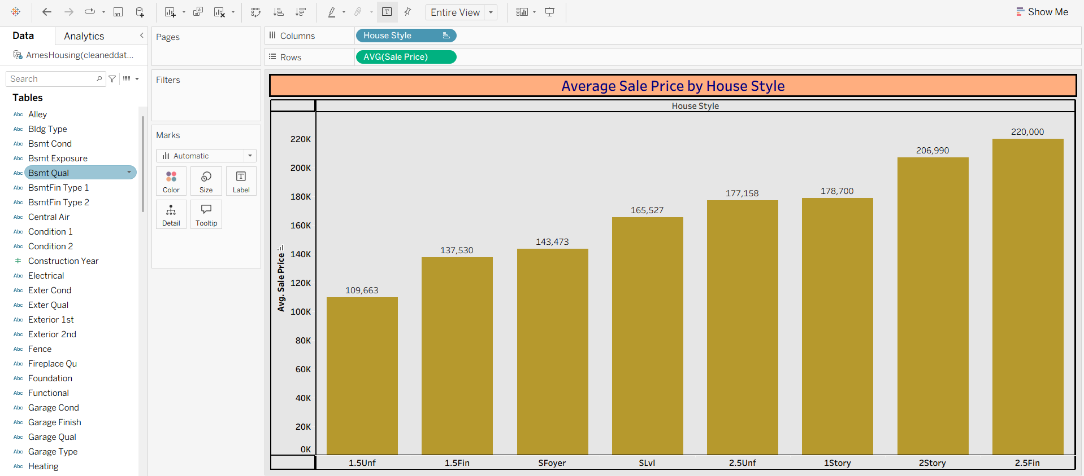

**Activity1.8**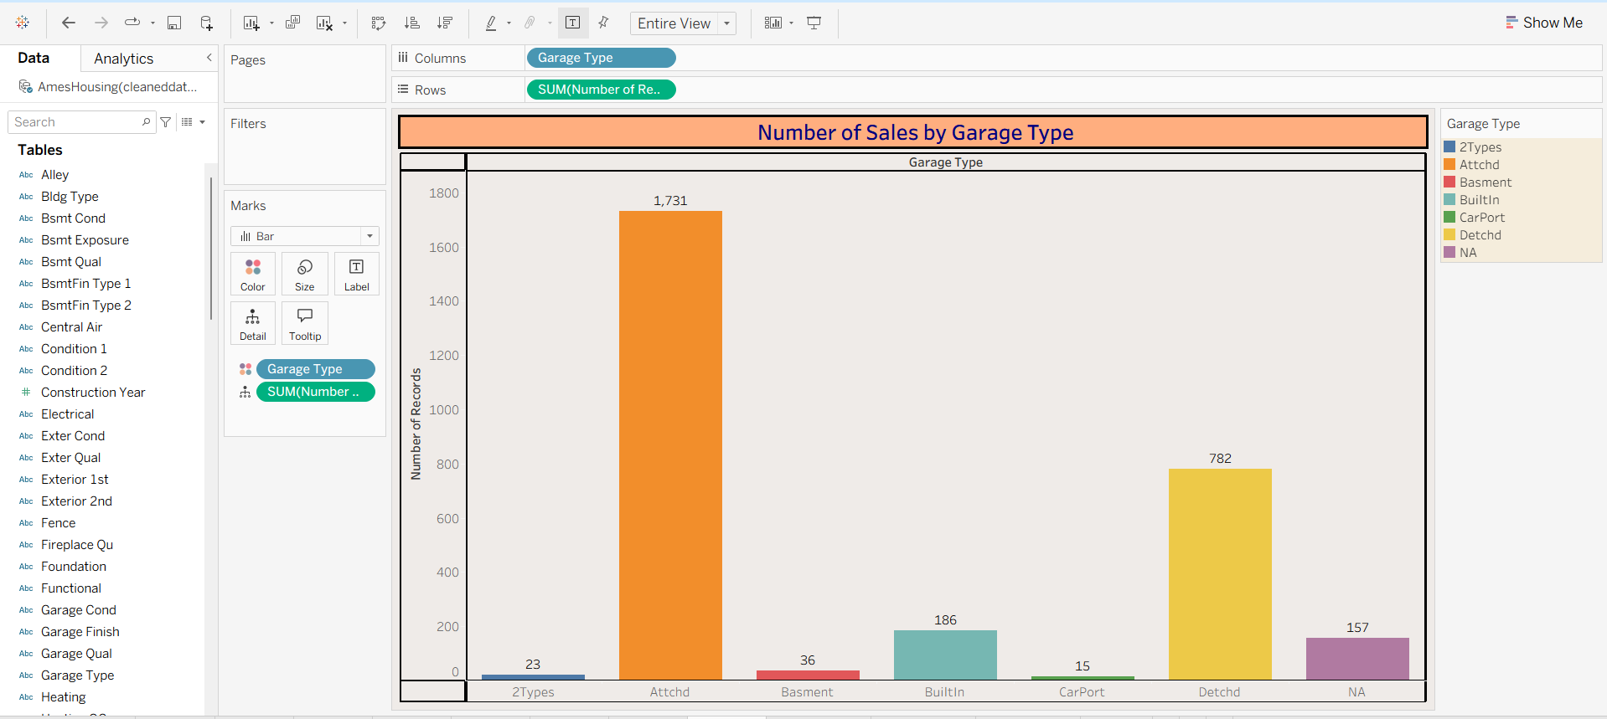

**Dasboard-1**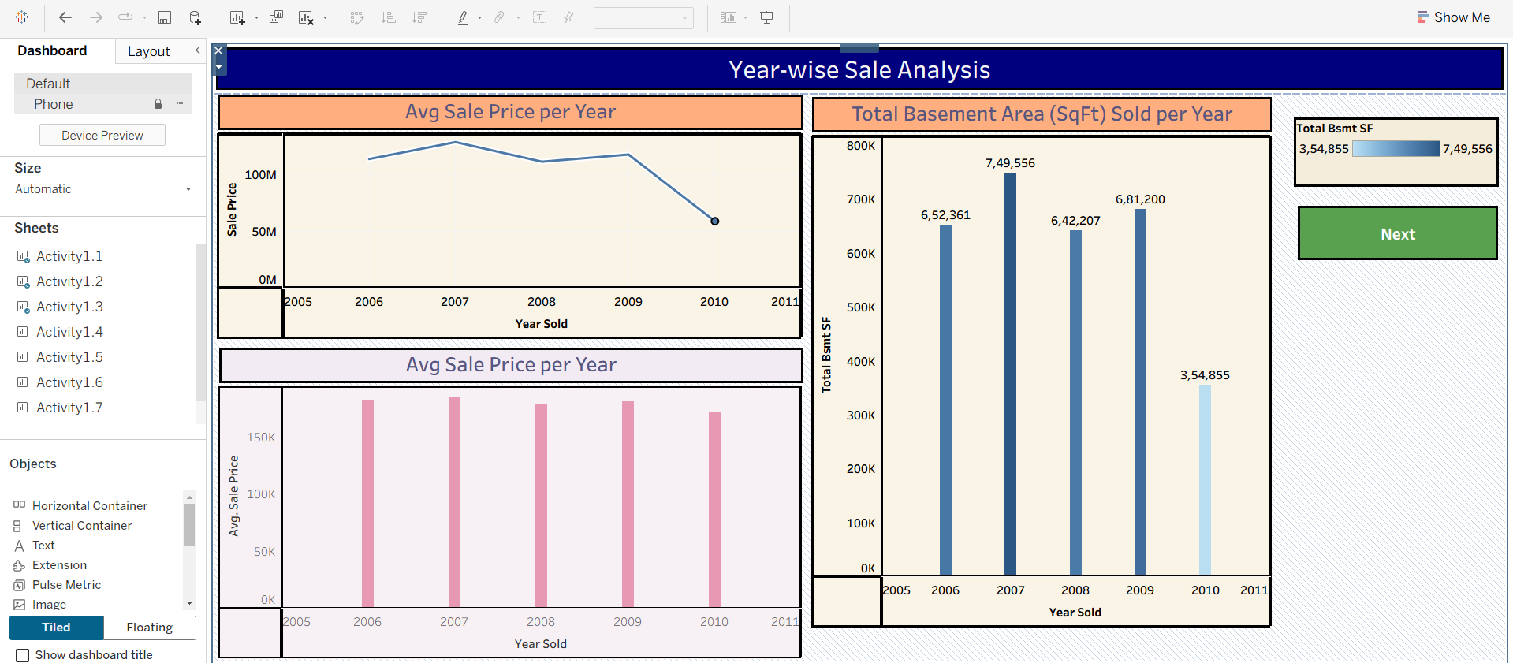

**Dashboard-2**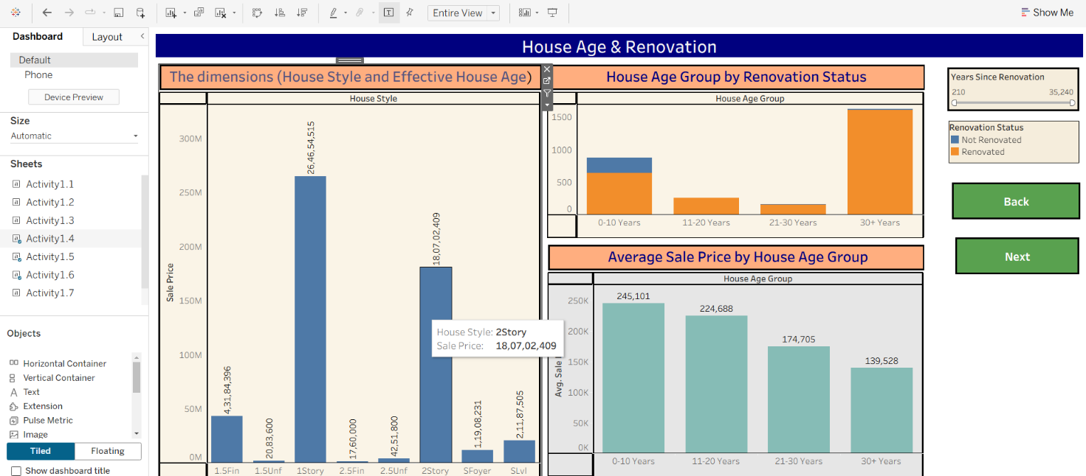

**Dashboard-3**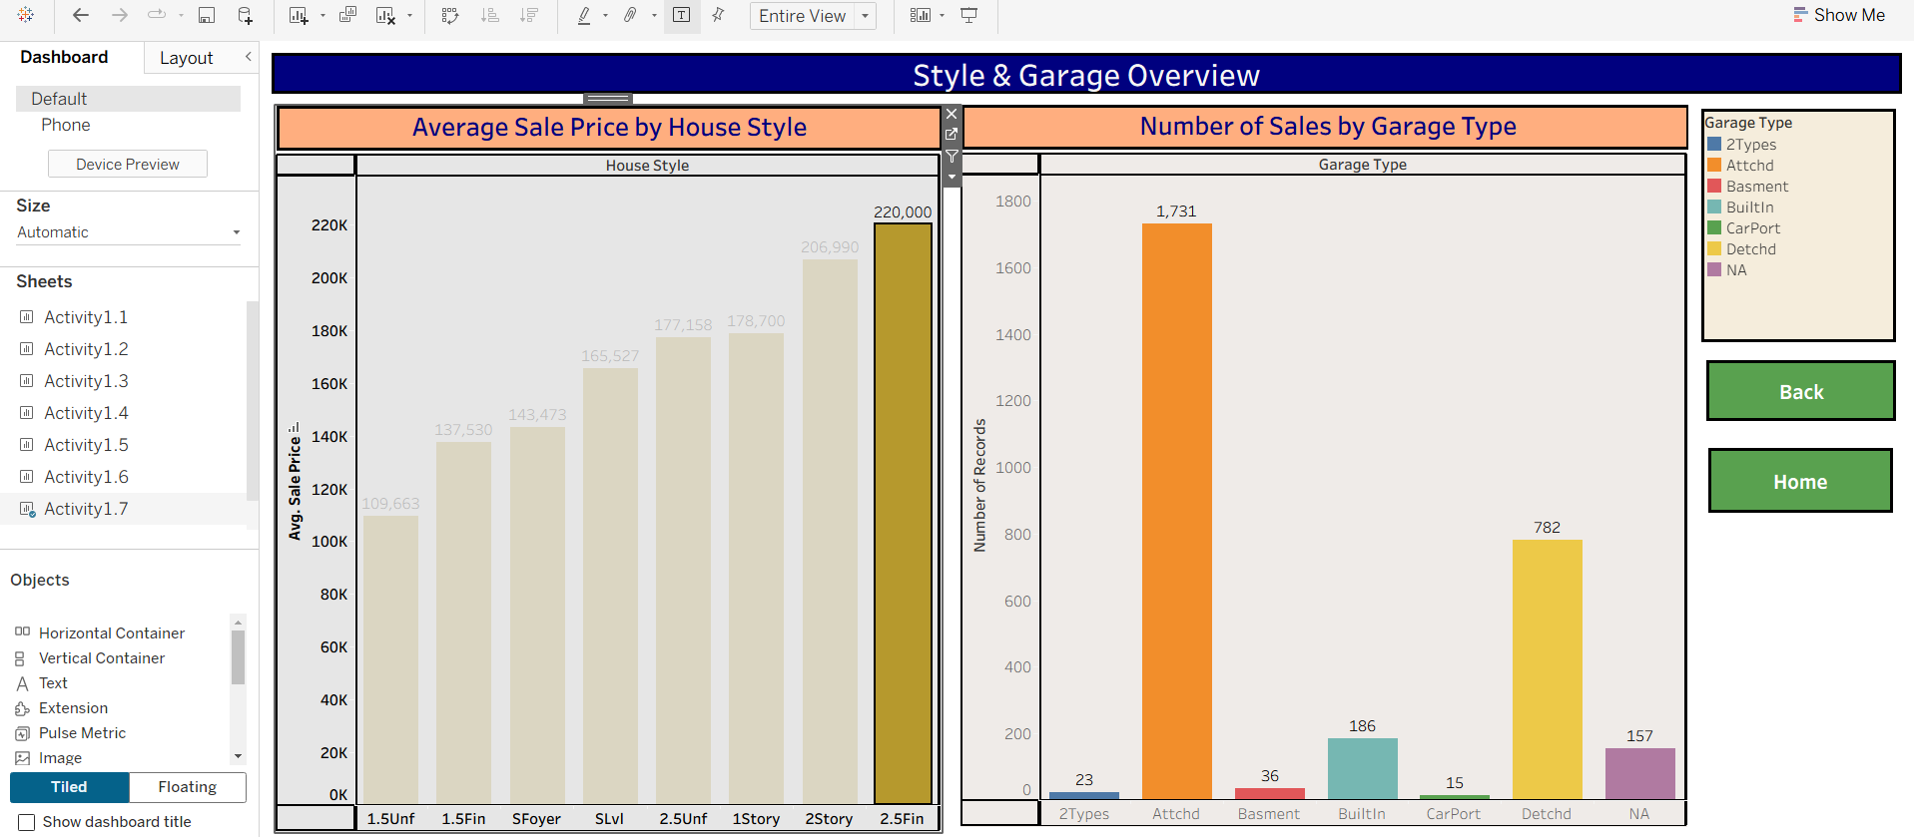

**Story**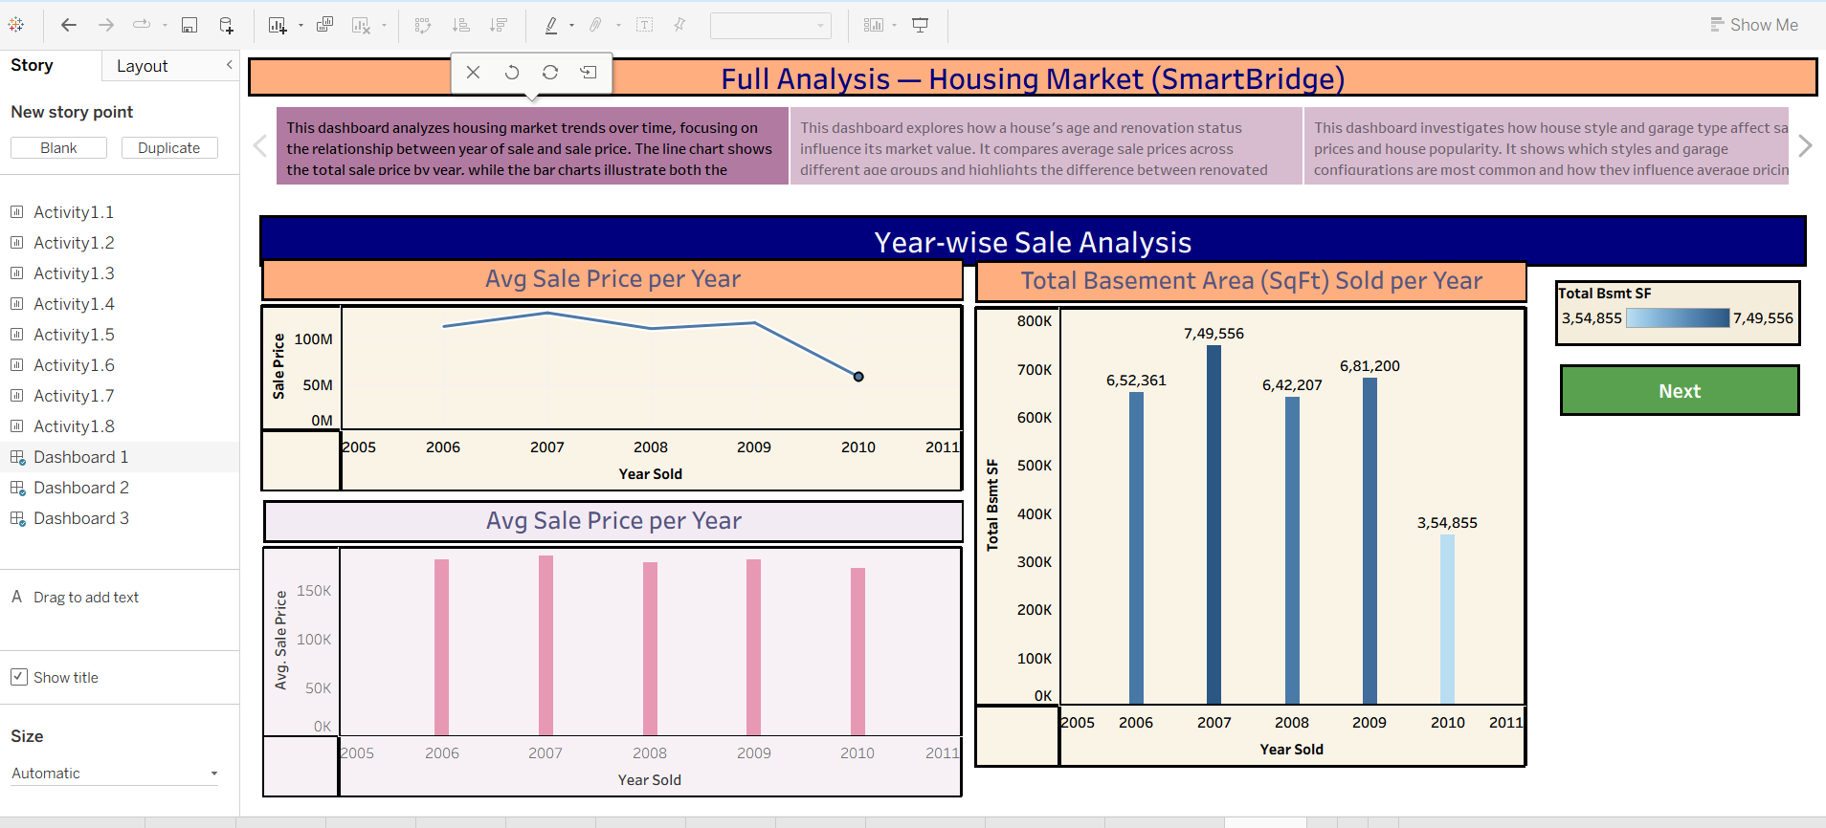

Tableau public link

[**https://public.tableau.com/views/VisualizingHousingMarketTrends_17508278225630/St ory1?:language=en-**](https://public.tableau.com/views/VisualizingHousingMarketTrends_17508278225630/Story1?:language=en-US&publish=yes&:sid=&:redirect=auth&:display_count=n&:origin=viz_share_link)

[**US&publish=yes&:sid=&:redirect=auth&:display_count=n&:origin=viz_share_link**](https://public.tableau.com/views/VisualizingHousingMarketTrends_17508278225630/Story1?:language=en-US&publish=yes&:sid=&:redirect=auth&:display_count=n&:origin=viz_share_link)

## 8. Advantages & disadvantages

**Advantages:**

1. **Interactive Dashboards**  
   The Tableau dashboards are designed with filters such as house style, garage type, renovation status, and house age group. These enable users to interactively explore how different property attributes affect sale prices.
2. **Smart Decision-Making for Stakeholders**  
   Homebuyers, real estate agents, and investors can use these dashboards to make informed decisions by analyzing how factors like effective house age, renovation, and basement area influence property value.
3. **Sequential Storytelling with Tableau**  
   The Tableau Story feature helps present insights from all dashboards in a clean, step-by-step format. It guides viewers through the trends in a meaningful sequence.
4. **Demographic & Property Trend Analysis**  
   Grouping by zipcode clusters and age groups helps compare regional trends and property characteristics. This brings out clear patterns in housing demand and pricing.
5. **Insightful Metrics & KPIs**  
   Calculated fields such as House Age, TotalAreaSqft, and SalePriceBin allow us to generate key insights like average sale price per house style or garage type—making analysis more precise.
6. **Web-Based Access Using Flask**  
   All dashboards are embedded in a simple Flask web app, making them easy to access and use via any browser, without the need for Tableau software.
7. **Scalable and Modular Approach**  
   The project is structured to allow future upgrades—new filters, datasets (like rental trends), or predictive models can be easily added later.
8. **User-Friendly Visual Design**  
   With Tableau's no-code interface, all visualizations were built using drag-and-drop. This allows even non-technical users to build or extend dashboards easily.

**Disadvantages:**

1. **Static Data Source**  
   The dashboards are based on a pre-cleaned CSV file. Real-time data updates or integration with live housing APIs is not currently implemented.
2. **Tool Dependency (Tableau Public)**  
   The project depends on Tableau Public, which lacks features like private publishing and row-level security—limiting sensitive or enterprise-level use.
3. **Learning Curve for New Users**  
   Though Tableau is intuitive, users unfamiliar with concepts like calculated fields, filters, or dashboard actions may require some training.
4. **No Predictive Analysis**  
   The analysis is descriptive and visual in nature. It does not include forecasting models or machine learning for price predictions.
5. **Web Rendering Limitations**  
   The embedded dashboards may not display properly on outdated browsers or small screens if the layout is not fully responsive.
6. **Manual Preprocessing**  
   Data cleaning, null value removal, and column renaming were done manually using Tableau Prep or Python. This may not scale efficiently for very large datasets.

1. **Conclusion:**

The project **"Visualizing Housing Market Trends: An Analysis of Sale Prices and Features using Tableau"** effectively showcases how complex housing data can be transformed into clear, interactive visual insights. By utilizing Tableau’s advanced visualization tools, we empower buyers, sellers, investors, and real estate agents to easily understand the key factors that influence house prices.

The dashboards allow users to quickly compare properties based on features such as number of bedrooms, total area, renovation status, house age, and location (zipcode groups). Integration with a Flask web application further enhances accessibility, making the dashboards available online without requiring Tableau Desktop.

Overall, this project bridges the gap between raw housing data and practical decision-making in real estate, enabling users to make confident, data-driven choices even without advanced technical skills.

1. **Future scope:**

1. **Live Data Integration**  
   Future versions can include real-time property listings and transaction data through APIs or live databases, providing up-to-date market insights.
2. **Machine Learning Forecasting**  
   Adding predictive models (e.g., regression or time-series forecasting) can help estimate future house prices and trends based on historical data.
3. **Rental Market Analysis**  
   Expanding the dashboard to analyze rental data will allow users to compare buying vs. renting options for better financial decision-making.
4. **Mobile Optimization**  
   Implementing a fully responsive design will ensure smooth performance and readability on mobile devices and tablets.
5. **Advanced Access Control**  
   Using Tableau Server or Tableau Online can enable secure, role-based access for different user groups, such as agents, investors, and analysts.
6. **Enhanced Location Intelligence**  
   Integrating geospatial data, maps, and demographic overlays (like school districts or crime statistics) can provide deeper location-based insights.
7. **Property Recommendation Engine**  
   Developing a smart recommendation feature can guide users to suitable property options based on their preferences and filters.

### GitHub Repository Link

[https://github.com/shoyab778/visualizing-housing-market-trends-an-analysis-of-sale-pricesand-features-using-tableau/tree/main](https://github.com/shoyab778/visualizing-housing-market-trends-an-analysis-of-sale-prices-and-features-using-tableau/tree/main)